

Maryland 4-H Animal Science – Dairy Project Record
Name |  |  | 4-H Age
Primary Club Name
Years in 4-H |  |  | Years in this Project
I have completed this record and believe all information to be complete and accurate.

Member’s Signature Date Parent’s Signature Date

What goals did you set for your project this year and did you achieve them?
1.

2.

3.

What were two things you learned from completing this project this year?
1.

2.

What is one thing you would like to improve or do differently with your project next year?
Life Skills
Describe the Life Skills you used and what you learned in relation to your project.
Example Table
I used one or more of these Life Skills from the Targeting Life Skills Wheel | What I learned as a result of using this skill.
HEAD  Example: Decision Making | I learned that I needed to be sure to budget my money when purchasing my rabbit projects so I would have enough to cover all of my expenses.
HEART  Example: Sharing | I learned how to give younger 4-H members pointers on how to fit and show their animals properly.
HAND  Example: Healthy Life Choices | I learned that animals don’t grow well unless they receive the proper food.
HEALTH  Example: Managing Feelings | I learned to control my feelings when I became frustrated that my pig would not cooperate to get loaded on the trailer

I used one or more of these Life Skills from the Targeting Life Skills Wheel | What I learned as a result of using this skill.
HEAD

HEART

HAND

HEALTH

The diagram below shows many of the Life Skills learned in 4-H:
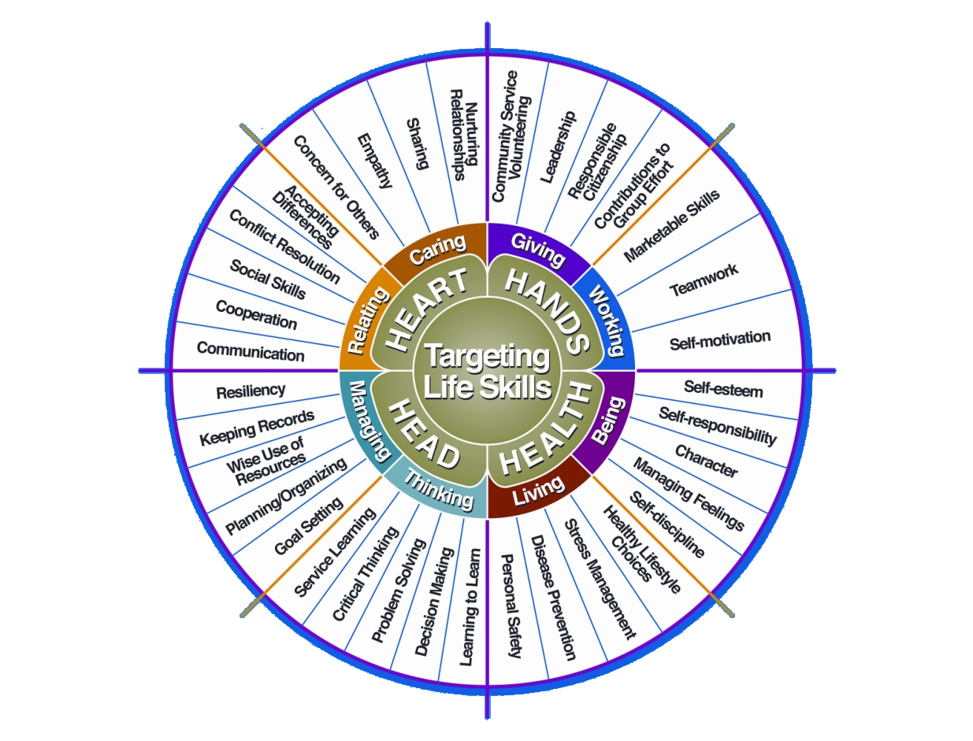

Courtesy of Iowa State University-Used with Permission 11/2012

MARYLAND

Youth Dairy Project Record

Wallet Size Picture

(Optional)

Name: _______________________________________________

County: ______________________________________________

Date of Birth: __________________________________________

Breed (s) (Specify): _____________________________________

For Judging Use Only:

Ayrshire | Brown Swiss | Guernsey | Holstein | Jersey | Milking Shorthorn | Red&White Holstein | Lineback | Crossbreed & other

Please refer to Maryland Youth Dairy Project Record Instructions
found at http://dairy.umd.edu

Maryland Youth Dairy Project Record
Personal Information Summary

Name _____________________________________
Mailing Address __________________________
__________________________
__________________________
Date of Birth __________________________
County __________________________
Telephone Number: __________________________
Parents/Guardians: __________________________
Please write the number of years you have carried this breed project in the corresponding boxes below:
Ayrshire | Brown Swiss | Guernsey | Holstein | Jersey | Milking Shorthorn | Red&White Holstein | Lineback | Crossbreed  & other

Please write the number of years you have been a junior member of the Maryland Youth Breed(s) Association(s) in the corresponding boxes below:

Ayrshire | Brown Swiss | Guernsey | Holstein | Jersey | Milking Shorthorn | Red&White Holstein | Lineback | Crossbreed  & other

This entry represents my own work and views

Signature of youth _______________________ Date:_______________

Parent/Guardian Signature_________________________ Date:_______________

Project/ Club Leader or Maryland Breed Association Representative:

Signature ______________ ___________________________ Date: _____________

Breed or Youth Organization ______________________________________________

CHECK LIST MARYLAND YOUTH DAIRY PROJECT RECORD

Dairy Youth Project Story □

Inventory □

Summary of Producing Cows □

Management Records

a. Health □

b. Breeding and Calving □

c. Dairy Project Financial Journal □

C. Activity Report Forms □

D. Photos and Clippings □

*******
Acknowledgements

The Maryland Dairy Youth Project Record and Maryland Youth Dairy Project Instructions were compiled by Dr. J. Lee Majeskie, Extension Dairy Specialist, and Gail Yeiser, volunteer leader, at the direction of the Maryland Purebred Cattle Association. Record keeping documents which were supplied by breed associations and 4-H programs are incorporated in this final product. Special thanks to the Maryland Purebred Dairy Cattle Association, Maryland 4-H Animal Sciences Program Committee and Frederick County 4-H Dairy Advisory Committee for their assistance and cooperation in completing this document.
[Adopted April 2005; revised July 2010]
INVENTORY OF OWNED/LEASED ANIMALS
(ALL animals from beginning & ALL breeds can be intermingled on this sheet)

Birthdate | Brd | Name | Reg. # | Score | Dam's Name | Sire's Name | If Sold, Date  and Reason | $  Value
3/10/01 | H | USNAD Broker Athena | 17313553 | 87 | USNAD Brian Daisy | Conant-Acres-Jy Broker-ET | 9/08/03  Dairy | $2500
Breed: A = Ayrshire; BS = Brown Swiss; G = Guernsey; H = Holstein; J = Jersey; MS = Milking Shorthorn; R&W = Red & White L = Lineback; X = Crossbred & other
SUMMARY OF ALL COWS IN THE HERD
Records of Cows Owned/Leased -- (Highest 305 day, actual)
(All animals from beginning & All breeds can be intermingled on this sheet)
 |  |  |  | Highest Record 305-Day Actual |  |  |  |  |  |  |  | Lifetime Production
Herd Name/Number | Breed | Score | PTA (if available) | Age | 2x/3x | Days | Pounds |  |  |  |  | Days | Milk | Fat | Protein
 |  |  |  |  |  |  | Milk |  | Fat | Protein
"Ghosty"/4285 | H | 86 | +720m | 4-4 | 2x | 305 | 24,015 | 987 |  | 768 |  | 845 | 57,198 | 2,345 | 1,887

Breed: A = Ayrshire; BS = Brown Swiss; G = Guernsey; H = Holstein; J = Jersey; MS = Milking Shorthorn; R&W = Red & White L = Lineback; X = Crossbred & other

MANAGEMENT RECORD – HEALTH
Juniors submit for 1 animal; Intermediates submit for 2 animals; Seniors submit for 3 animals; Please note if your herd has less than required number for your age division.

_____________________
USE SEPARATE FORM for EACH INDIVIDUAL ANIMAL Barn Name or Number

Date of Birth: Birth Weight: Tattoo or Ear Tag: Right: Left:

Date | Vaccination, Illness, Problem | Treatment | Time Period | Est. Expense
8/4/03 | Dehorned | Electric dehorner | life | N/A
10/8/03 | Calfhood Vaccination | Brucellosis | life | $6.25
3/2/04 | Ringworm | Agrilab ringworm | 1 mo. | $1.45

Date Sold: Reason: (Please check appropriate reasons) Dairy _____ , Beef: Low production _____ , Reproductive problem _____ ,
Mastitis _____ , Calving problem _____ , Udder problem _____ , Leg problem _____ , Disease_____ . Died: __________________

MANAGEMENT RECORD -- BREEDING AND CALVING
Juniors submit for 1 animal; Intermediates submit for 2 animals; Seniors submit for 3 animals;
Please note if your herd has less than required number for your age division. Please note if your animal is too young for you to report on

______ __________
Breed USE SEPARATE FORM for EACH INDIVIDUAL ANIMAL Barn Name or Number

Date Bred | Service Sire  or AI Code | Date Due | Date Calved | Remarks  (calving difficulties) | Sex of Calf | Ear Tag | Remarks
2/6/03 | 9H760 | 11/8/03 | 11/7/03 | Vet help | F | 1480 | 90 lbs
3/1/04 | 9H810 | 12/8/05 |  | Not calved
Note: Make sure to record all breeding records, whether they resulted in pregnancy or not.
Dairy Project Financial Journal for ________
Beginning year - current year; or current year

Include information for this year. Past years may be included. Add current year at end of chart below. Page 4 (project financials) of 4-H project record sheet may be included or use chart below.

Income is all the monies you receive from the sale of services, products, and premiums for your dairy project. Expenses are all the items that you paid for or would have needed to pay for to support your dairy project. Remember to include items such as: AI Tech visits, semen, ultra sound, show equipment, cost of animal, fans, shavings, transportation, feed - if known. “Gifted” items may also be included.

Date | Description of Income or Expenses | Income | Expenses
 | TOTAL Project Income & Expenses:

Income:_______________________________

Expenses:_____________________________

Profit (+) or Loss (-) :____________________

Dairy Activities
Junior and Intermediates begin with earliest year and add to bottom. Seniors refer to Maryland Youth Dairy Project Record Instructions found at http://dairy.umd.edu

Year | Type of Activity | Special Achievement / Leadership Role | Level * | Breed Code**
2003 | Maryland State Fair Wills Show | 3 animals shown; 1st F&S | S | MS
2004 | Wills Show | 2 animals shown – res. champ | D | BS

* Indicates level of the activity as one of the following: “L” local club event: “C” county wide level; “D” district event; “S” state wide event; “R” regional event; “N” national event

** Breed Code: A = Ayrshire; B = Brown Swiss; G = Guernsey; H = Holstein; J = Jersey; MS = Milking Shorthorn;
RW = Red and White; L = Lineback; X = Crossbred & all other
OTHER 4-H / FFA ACTIVITES
Junior and Intermediates begin with earliest year and add to bottom. Seniors refer to Maryland Youth Dairy Project Record Instructions found at http://dairy.umd.edu

Year | Type of Activity | Special Achievement / Leadership Role | Level *
2003 | Rolling Hills 4-H Club Bake Sale | Publicity Chairman | L
2004 | Cecil County Fair | 15 craft exhibits – grand champion | C

* Indicates level of the activity as one of the following: “L” local club event: “C” county wide level; “D” district event; “S” state wide event; “R” regional event; “N” national event

SCHOOL ACTIVITIES
Junior and Intermediates begin with earliest year and add to bottom. Seniors refer to Maryland Youth Dairy Project Record Instructions found at http://dairy.umd.edu

Year | Type of Activity | Special Achievement / Leadership Role | Level *
2003 | Marching Band | Flute – section leader | L
2004 | Honor Society |  | L

* Indicates level of the activity as one of the following: “L” local club event: “C” county wide level; “D” district event; “S” state wide event; “R” regional event; “N” national event
COMMUNITY / CHURCH ACTIVITIES
Junior and Intermediates begin with earliest year and add to bottom. Seniors refer to Maryland Youth Dairy Project Record Instructions found at http://dairy.umd.edu

Year | Type of Activity | Special Achievement / Leadership Role | Level *
2003 | Habitat for Humanity | Concrete manager – 2 weeks | D
2004 | Relay for Life – MD |  | S

* Indicates level of the activity as one of the following: “L” local club event :”C” county wide level; “D” district event; “S” state wide event; “R” regional event; “N” national event

