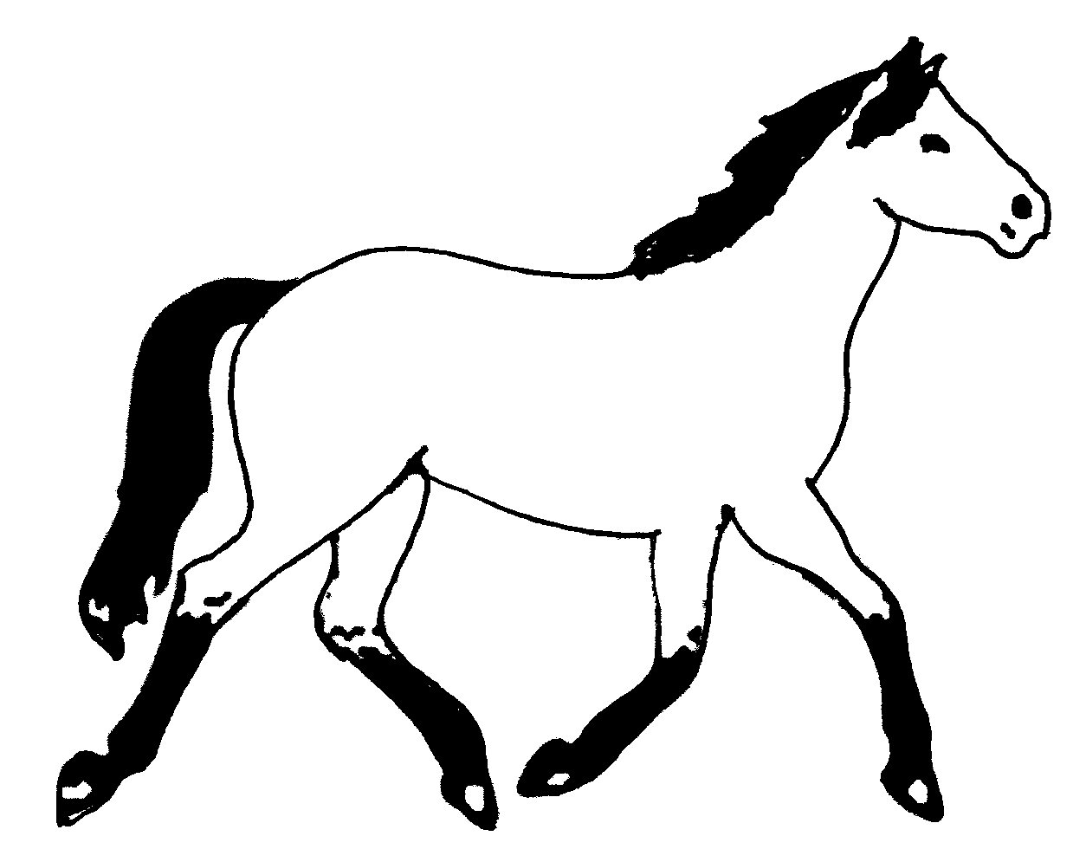
Maryland 4-H Animal Science – Horse Project Record
Name |  |  | 4-H Age
Primary Club Name
Years in 4-H |  |  | Years in this Project
I have completed this record and believe all information to be complete and accurate.

Member’s Signature Date Parent’s Signature Date

What goals did you set for your project this year and did you achieve them?
1.

2.

3.

What were two things you learned from completing this project this year?
1.

2.

What is one thing you would like to improve or do differently with your project next year?
Life Skills
Describe the Life Skills you used and what you learned in relation to your project.
I used one or more of these Life Skills from the Targeting Life Skills Wheel | What I learned as a result of using this skill.
HEAD  Example: Decision Making | I learned that I needed to be sure to budget my money when purchasing my rabbit projects so I would have enough to cover all of my expenses.
HEART  Example: Sharing | I learned how to give younger 4-H members pointers on how to fit and show their animals properly.
HAND  Example: Healthy Life Choices | I learned that animals don’t grow well unless they receive the proper food.
HEALTH  Example: Managing Feelings | I learned to control my feelings when I became frustrated that my pig would not cooperate to get loaded on the trailer

I used one or more of these Life Skills from the Targeting Life Skills Wheel | What I learned as a result of using this skill.
HEAD

HEART

HAND

HEALTH

The diagram below shows many of the Life Skills learned in 4-H:
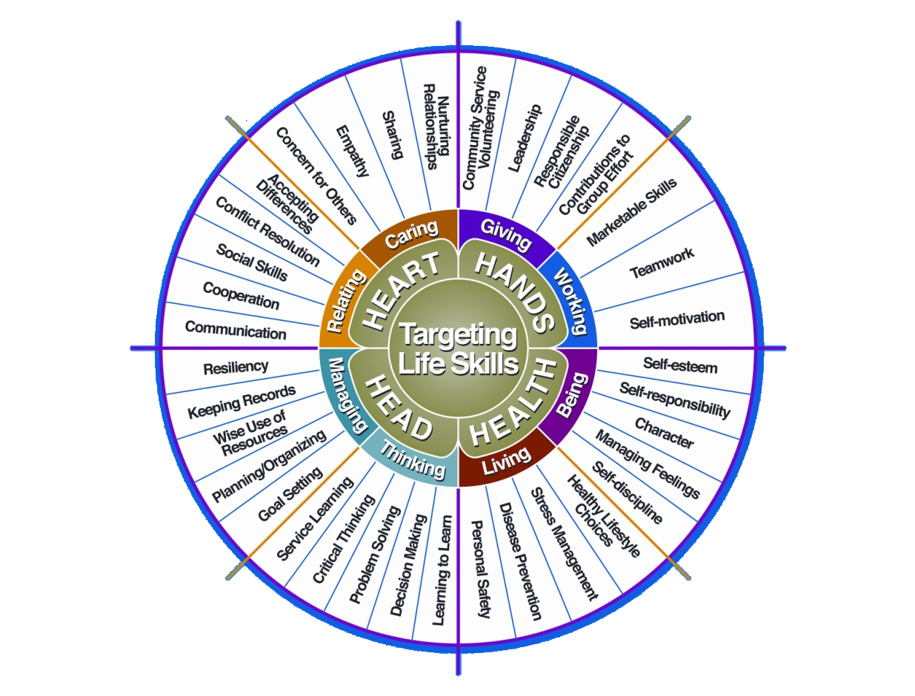

Courtesy of Iowa State University-Used with Permission 11/2012

Project Activities
Include: Field Trips, Skillathon, Judging, Workshops, Quality Assurance, Class Participation, etc.
All project activities listed should be about this project area only.
Date | Name of Activity/Event | Location  (School, Club, County, Regional, State, National etc.)

Project Communications
All project communications listed should be about this project area only.
Date | Type of Communication  (Speech, Demonstration, Visual Presentation, etc.) | Title | Location  (School, Club, County, Regional, State, National etc.)

Project Exhibits
Include: Fairs, Shows, Community Events, etc.
All project exhibits listed should be for projects in this area only.
Date | Horse’s Name  (If Applicable) | Exhibit/Class | Event/Activity | Placing  (if applicable)

Table 1: HORSE/PONY INFORMATION
Complete information for each project animal.
 | Horse #1 | Horse #2 | Horse #3
Show/Registered Name
Barn Name
Color
Markings (be specific)
Height
Breed
Breed Registry Information
(If Applicable)
Animal’s Date of Birth

Table 2: Feed Expenses

Date  Purchased | Type of feed (grain, mix, hay, supplement, pasture, silage) | $/lb (total cost divided by lbs) | Pounds (lbs) | Total Cost
Total pounds and total feed costs

Table 3: Health and Veterinary Record and Expenses
Record routine and emergency veterinary visits and include specific shots, Coggins, dentistry, deworming,
test(s) performed, etc. If you lease a horse and are not directly responsible for these expenses,
you must still complete these sections.
Date | Horse’s Name | Reason For Treatment or Veterinary Visit (Vaccines, Health Papers, Routine Checks) | Treatment | Cost
Total Veterinary Costs |  |  |  | $

Table 4: Farrier Record and Expenses
Record each Farrier visit as it occurs. Place an X in the appropriate box for trim, shoe, or reset.
Date | Horse’s Name | Trim | Shoe | Reset | Cost
 | Total Farrier Expenses |  |  |  | $

Table 5: All Other Expenses Record
Includes: hauling, tack, equipment, insurance, board, membership fees, bedding, training, etc.
Date | Expense | Cost
Total Other Expenses |  | $

Table 6: Income Record
Includes all monies received as part of your project (premiums, sale of services, sale of horse(s), etc.).
Date | Income Explanation | Amount
Total Income |  | $

Table 7: Equine Showmanship & Equitation Standards Information
Please complete the chart regarding the Maryland 4-H Equine Showmanship and Equitation Standards tiers (or Equivalent Levels from the Previous Horsemanship Standards Program) that you have completed. Include the month and year for each tier that has been completed.
 | Knowledge | Handling/Riding
Tier 1
Tier 2
Tier 3
Tier 4

Financial Summary: Please make sure to use the above totals.

Determine how much money you made or lost on your project animals. You can determine your profit (or loss) by:

- Add Income
- All Income (Table 6) $ ________

Total Income (A) $ _________
- Add Expenses
- Feed Expenses (Table 2) $________
- Veterinary Expenses (Table 3 ) $ ________
- Farrier Expenses (Table 4) $ ________
- All Other Expenses (Table 5) $________

Total Expenses (B) $ ________

Subtract B from A to get profit or loss Total $________ (profit or loss)

University programs, activities, and facilities are available to all without regard to race, color, sex, gender identity or expression, sexual orientation, marital status, age, national origin, political affiliation, physical or mental disability, religion, protected veteran status, genetic information, personal appearance, or any other legally protected class.

1/2013, updated 1/2022

