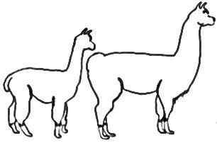
Maryland 4-H Animal Science – Camelids Project Record
Name |  |  | 4-H Age
Primary Club Name
Years in 4-H |  |  | Years in this Project
I have completed this record and believe all information to be complete and accurate.

Member’s Signature Date Parent’s Signature Date

Please indicate your Animal Science Project Area
☐Llama | ☐Alpaca

Are your project animal(s) ☐Owned ☐Leased

What goals did you set for your project this year and did you achieve them?
1.

2.

3.

What were two things you learned from completing this project this year?
1.

2.

What is one thing you would like to improve or do differently with your project next year?
Life Skills
Describe the Life Skills you used and what you learned in relation to your project.
Example Table
I used one or more of these Life Skills from the Targeting Life Skills Wheel | What I learned as a result of using this skill.
HEAD  Example: Decision Making | I learned that I needed to be sure to budget my money when purchasing my rabbit projects so I would have enough to cover all of my expenses.
HEART  Example: Sharing | I learned how to give younger 4-H members pointers on how to fit and show their animals properly.
HAND  Example: Healthy Life Choices | I learned that animals don’t grow well unless they receive the proper food.
HEALTH  Example: Managing Feelings | I learned to control my feelings when I became frustrated that my pig would not cooperate to get loaded on the trailer

I used one or more of these Life Skills from the Targeting Life Skills Wheel | What I learned as a result of using this skill.
HEAD

HEART

HAND

HEALTH

The diagram below shows many of the Life Skills learned in 4-H:
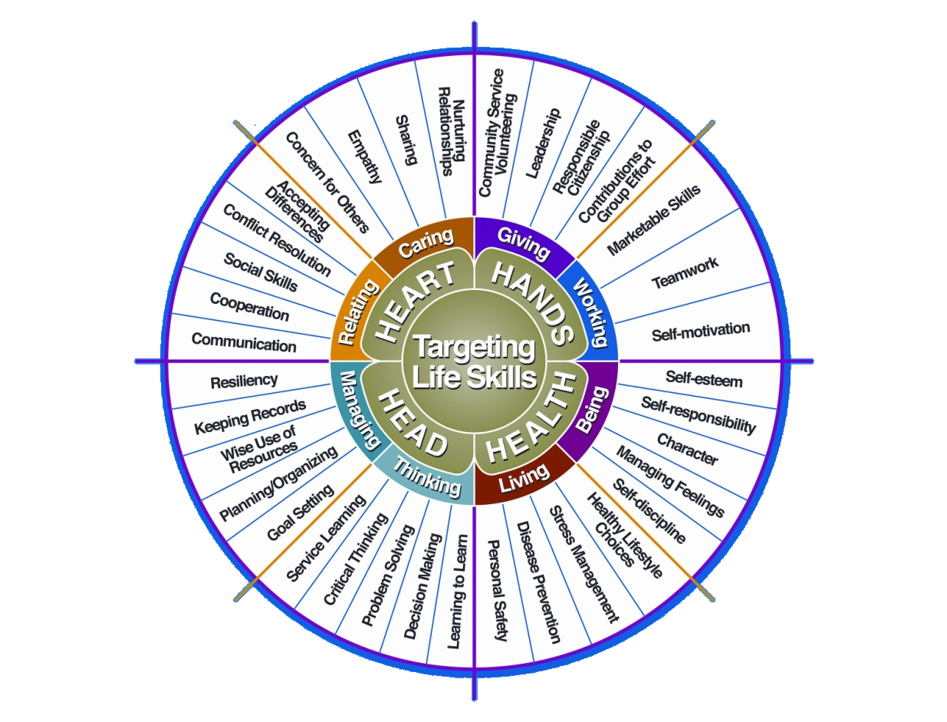

Courtesy of Iowa State University-Used with Permission 11/2012

Project Activities
Include: Field Trips, Skillathon, Judging, Workshops, Quality Assurance, Class Participation, etc.
All project activities listed should be about this project area only.
Date | Name of Activity/Event | Location  (School, Club, County, Regional, State, National etc.)

Project Communications
All project communications listed should be about this project area only.
Date | Type of Communication  (Speech, Demonstration, Visual Presentation, etc.) | Title | Location  (School, Club, County, Regional, State, National etc.)

Project Exhibits
Include: Fairs, Shows, Community Events, etc.
All project exhibits listed should be for projects in this area only.
Date | Exhibit | Location/Event | Placing  (if applicable)

Table 1: Alpaca Information
Complete information for each project animal.
 | Alpaca #1 | Alpaca #2 | Alpaca #3
Name of Animal
Color
Markings (be specific)
Height
Breed Registry Information
(If Applicable)
Animal’s Date of Birth
Sex

Table 2: Feed Expenses

Date  Purchased | Type of feed (grain, mix, hay, supplement, pasture, silage) | $/lb (total cost divided by lbs) | Pounds (lbs) | Total Cost
Total pounds and total feed costs

Table 3: Health and Veterinary Record and Expenses
Record routine and emergency veterinary visits and include specific shots, dentistry, deworming,
test(s) performed, etc. If you lease an alpaca and are not directly responsible for these expenses,
you must still complete these sections.
Date | Alpaca’s Name | Reason For Visit  (Vaccines, Health Papers, Routine Checks) | Treatment | Cost
Total Veterinary Costs |  |  |  | $

Table 4: All Other Expenses
Includes: Halter, Bedding, Training, etc.
Alpaca’s Name | Date | Explanation of Items | Cost
Total All Other Expenses

Table 5: All Income
Includes: Premiums, Selling Offspring, Fiber, etc.
Date | Description of Income | Income
Total Income

Table 6: Training Record
Check commands or exercises that your alpaca has learned.
Obstacles | Alpaca’s Name | Alpaca’s Name | Alpaca’s Name
Leading Forward
Backing Up/Reverse Movement
Lead Up Stairs (Bridge)
Lead Across Teeter Totter
Hurdles
Hula Hoop (Step Inside and Out)
Maneuvering A Maze (Obstacles or Cones)
Sprinting with Controlled Stop
Loading and Unloading from Trailer
Entering Through Gate
Other (Write In)
Public Relations
Noise (Cans)
Public Interaction (Petting/Towel on Back)
Moving Large Objects (Umbrella)
Tying a Secure Knot
Other (Write In)

Table 7: Daily Care and Routine
Explain the daily care and routine you follow with your alpaca
Alpaca’s Name | Explanation

Financial Summary: Please make sure to use the above totals.

Determine how much money you made or lost on your project animals.
You can determine your profit (or loss) by:

- Income

- Income Total (Table 5) $ ________

Total Income (A) $ ________

- Add Expenses

- Feed Expenses (Table 2) $ ________
- Health and Veterinary Expenses (Table 3) $ ________
- All Other Expenses (Table 4) $ ________

Total $ ________

Subtract B from A to get profit or loss Total $ ________ (profit or loss)

University programs, activities, and facilities are available to all without regard to race, color, sex, gender identity or expression, sexual orientation, marital status, age, national origin, political affiliation, physical or mental disability, religion, protected veteran status, genetic information, personal appearance, or any other legally protected class.

1/2013, updated 1/2022

