^{For Immediate Release}
^{Date: 02/12/2026}

Bear Creek 4-H Club News

Reporter, Tucker Fratz
The year 2026 is off to a great start for Bear Creek 4-H. Our club is thankful to the Deep Creek Volunteer Fire Department for allowing us the use of their facility for our monthly meetings. Their support helps make it possible for our members to gather, learn, and plan exciting activities throughout the year.
So far, we have welcomed new members, elected officers, and begun planning upcoming field trips and events. At our January meeting, the club elected the following officers for the year: President Kenzie Pysell, Vice-President Beau Beitzel, Secretary Emmalyn DeWitt, Treasurer Grant Guard, Club Reporter Tucker Fratz, and Photographer Allie Fratz.
During the meeting, members also planned a field trip for our February gathering and discussed attending the March Achievement Program, scheduled for March 29 at the Ag Heritage Hall. We also talked about important schedule updates, including changes to the dates for the 69th Annual Garrett County Agriculture Fair and the updated time for the Livestock Auction.
In addition, members reviewed the new date for the 10th Annual Ag Bash, which is now scheduled for April 25, 2026. These events give our members great opportunities to learn more about agriculture, build leadership skills, and get involved in the community.
It has been an exciting start to the year for Bear Creek 4-H, and we are looking forward to everything 2026 has in store for our club.

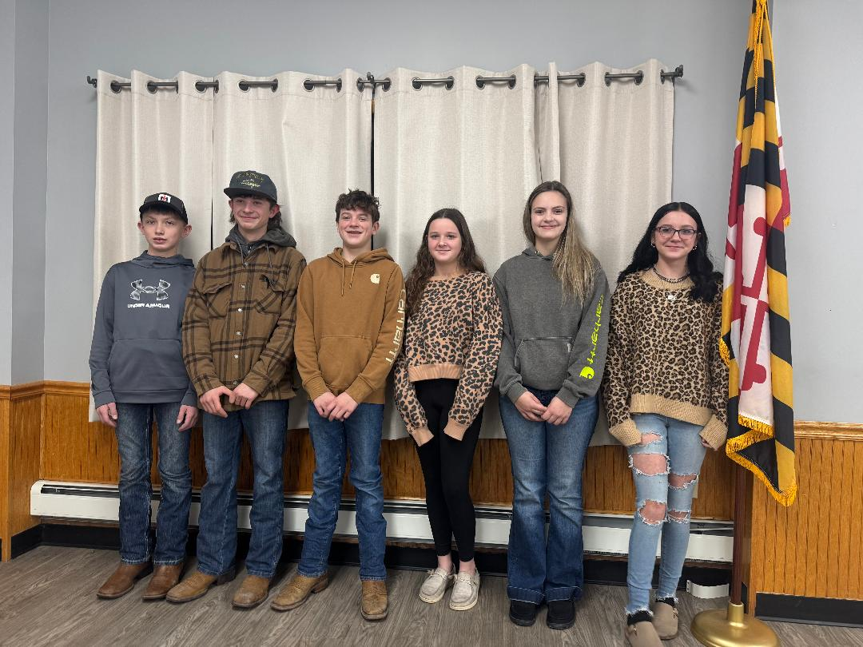
2026 Bear Creek 4-H Club Officers pictured from left to right: Grant Guard: Treasurer, Beau Beitzel: Vice-President, Tucker Fratz: Club Reporter, Allie Fratz: Photographer, Kenzie Pysell: President, Emmalyn DeWitt: Secretary.

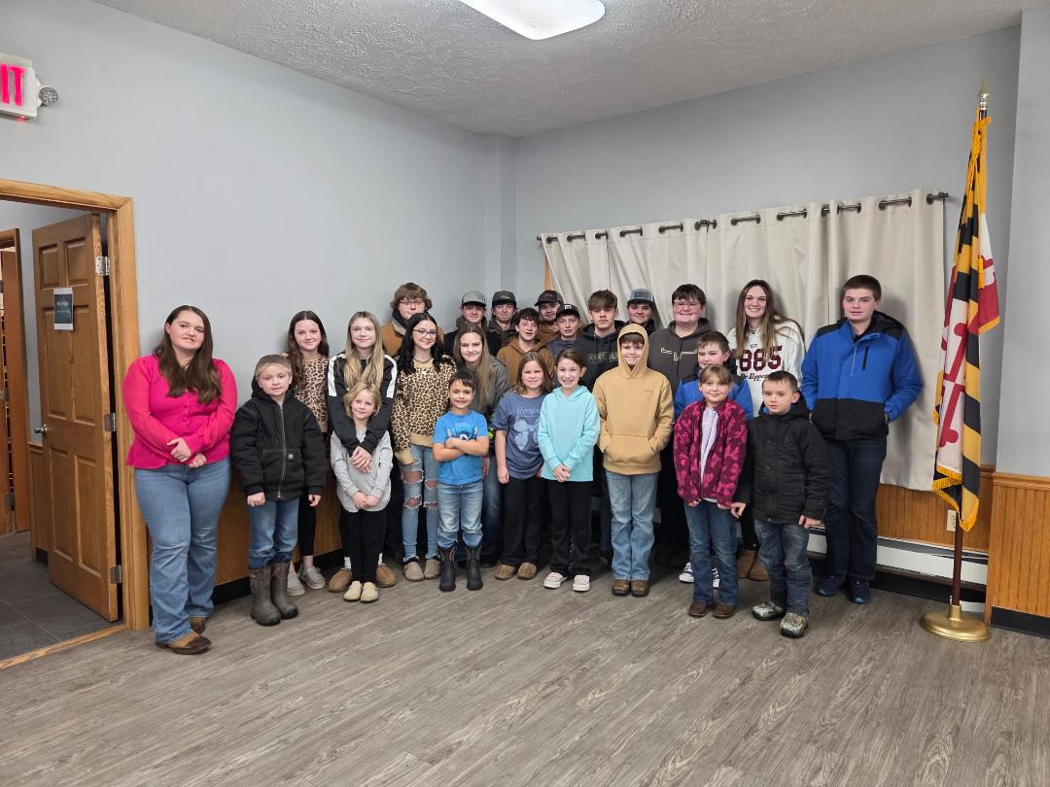
Bear Creek 4-H Club Members are pictured starting in the front from left to right:
1st Row: Kayleigh Smearman, James Close, Lyndy Fratz, Adrian Pysell, Adeline Fratz, Brinley Beitzel, Lane Close, Bransen Reese, Joslynn Smearman, Brayson Smearman
2nd Row: Allie Fratz, Abigail Artice, Emmalyn DeWitt, Kenzie Pysell, Tucker Fratz, Grant Guard, Leland Close, Parker Hook, Kaylie Reese, Brayden Reese
3rd Row: Jett DeWitt, Hunter Beitzel, Beau Beitzel, Landen Beitzel, Mason Keller
^{Members not pictured:}
Kimber Wass, Noah Wass, Nolan Wass, Reese Wass & Reed Lowdermilk

